How best to run the Fast FID August 2006

Do not use the pressure regulators on the FFID module as they are not very high quality. Changes in pressure upstream of these regulators

Temperature of Thermocouple attached to FFID head on overnight run on the 18/7/06
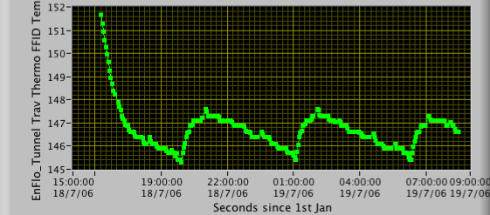
Corresponding Drift over the same period
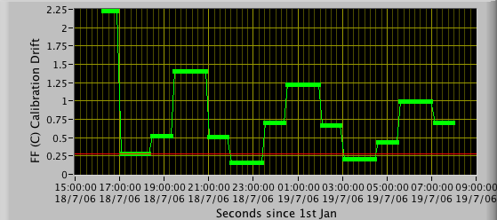

This behaviour was shown to be caused by the change in compressed air pressure. The sharp increases were associated with the compressor running and the longer decreases associated with the pressure vessel slowly emptying. Assuming that the required flowrate of compressed air was roughly constant overnight, thus the 5 hour time period was coming from this cycle.

It was found that the regulator upstream of the air purifier was screwed down too much so that it was not regulating the oscillating line pressure. This was solved by setting this pressure to 4.75 bar. The next night no such temperature fluctuations were observed.

Overnight Run 20/7/06

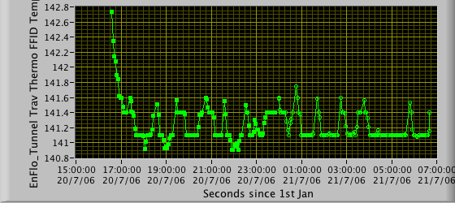
The remaining spikes in the time trace correlate with calibrations. It would appear that when calibrating the temperature of the FID rises slightly. Not exactly sure of the mechanism for this.

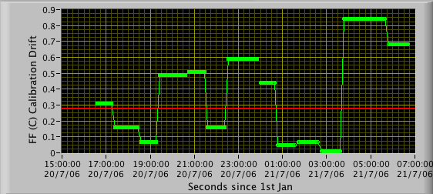

There is an alarming correlation between FID Temp and the A_Tunnel velocity. This gave rise to calibration drifts of the order of 5%.
